Jyle Darling

M093437

Rapid App Development

AT1

Table of Contents

Business Resources 1

Q1. 1

Q2. 1

Q3. 2

Development Tools 3

Q4. 3

Q5. 3

Q6. 5

Q7. 7

Q8. 7

Q9 7

Software Development 8

Q10. 8

Q11. 11

Rapid App Development 12

Q12. 12

Q13. 12

Q14. 13

Q15. 14

References 15

# Business Resources

### Q1.

**Provide a summary of the most common industry-accepted hardware and software that is used by Australian businesses.**

In Australian businesses the list of hardware and software used is quite extensive, so it’s best to put these items into broader categories in order to better summarise what is used.

Hardware that is used on the most basic level would consists of computers, laptops, tablets or mobile phones, and the associated hardware used to communicate with these devices, i.e. Mouse and keyboard These items allow users to actually work in a modern environment, but these devices alone can’t communicate with each other. (Pratt, 2013)

In order for the above mention hardware to communicate with each other, and boost its usefulness in the workplace, other hardware and software is required. Network infrastructure, like Lan, Wan, or internet connections, Network storage or Servers that provide additional functionality and Cloud systems used to host data remotely, are all types valid methods that allow computers to ‘talk’ with each other, and increase the output of workers using computers. However when allowing computer to communicate with each other, it is important to monitor and specify who is talking. (Pratt, 2013)

Security and the peace of mind that comes with it is another important factor when referring to business hardware and software. Physical security hardware and surveillance equipment protect against theft or damage of physical hardware, while software in these categories help to protect against malicious attacks or theft of company data. However another important factor of security comes to back up devices. (Pratt, 2013)

These back up devices may be processes or devices used to store company data in a secondary location to protect against data loss events. Another form of these are back up power systems like batteries or generators that will work to keep things running in the event of power outages or other natural disaster events. (Pratt, 2013)

### Q2.

**Provide a definition and description of two major/popular operating systems used in the business world.**

While the list if operating systems used by business seems to be ever growing based on the individual needs of each business, it’s safe to say that two popular systems used are Windows 10, and Windows Server.

Windows 10 is a series of operating systems developed by Microsoft. One of its primary aims is to unify the Windows experience across multiple devices like computers, tablets and smart phones. Windows 10 would be the industry standard for operating systems used by computers in many different fields of work, as well as personal use. As the operating system is actively maintained and patched frequently, many businesses choose this operating system. (Christensson, WIndows 10 Definition, 2015)

Windows Server 2019 is used by many business around the world to manage employee computers for specific software and data functionality. It is an important piece of software used for IT teams in managing computer systems used by medium to large businesses. It provides many system insights and data storage services that help to monitor a network, and provide simple transfer of data between computers. (Roman, 2018)

### Q3.

**Describe input and output drivers generally associated with Personal Computers use in a business environment.**

Drivers are computer programs that control, operate or facilitate a particular device attached to a computer. Drivers control the software that enable a computer to correctly communicate with the device. Many device drivers that mange the input and output of information and are referred to as I/O drivers. These are used for devices such as printers, video adapters or graphics cards, network cards, audio devices like speakers or headsets, data storage devices such as hard disk drives or flash drives, or CD-ROM drives. (Microsoft Docs, 2018)

# Development Tools

### Q4.

**Provide a description of the major industry accepted prototyping tools.**

Prototyping tools allow designers and clients to collaborate better while being in the same context rather than having conflicting perspectives. The clients get a visual overview of what is actually going to be made. It helps teams to build understanding, to explore options and barriers that only become visible when you build and test something. At the end of the day, prototyping tools become a platform for full creativity and experimentation for the product team. (Techlabs, 2018)

One of the most popular prototyping tools currently used for UI and UX design is Invision. With InVision’s project management page, you can organise design components into a status workflow. You can set columns for To-do, In progress, Needs review, and Approved, and drag and drop your design components into the appropriate column. It allows the user to upload a range of different file image types, as well as push and pull integration with many apps like Dropbox and Trello (Techlabs, 2018)

### Q5.

**Provide a definition of Object-Oriented Programming and then a description of three major OOP languages. Give a code example of each using a binary search algorithm.**

Class based Object-orientated programming (OOP) is defined as a programming paradigm based on the concept of "objects", which can contain data and code: data in the form of fields, and code, in the form of procedures. A feature of objects is that an object's own procedures can access and often modify the data fields of itself. Some examples of OOP code languages are:

#### C#.

C# is a modern, general-purpose, object-oriented programming language developed by Microsoft and approved by European Computer Manufacturers Association (ECMA) and International Standards Organization (ISO).

A Binary search algorithm written in C#:

public static object BinarySearchIterative(int[] inputArray, int key)

{

int min = 0;

int max = inputArray.Length - 1;

while (min <=max)

{

int mid = (min + max) / 2;

if (key == inputArray[mid])

{

return ++mid;

}

else if (key < inputArray[mid])

{

max = mid - 1;

}

else

{

min = mid + 1;

}

}

return "Nil";

}

#### Java.

Java is a high-level programming language developed by Sun Microsystems. The Java syntax is similar to C++, but is strictly an object-oriented programming language. For example, most Java programs contain classes, which are used to define objects, and methods, which are assigned to individual classes. Unlike Windows executables (.EXE files) or Macintosh applications (.APP files), Java programs are not run directly by the operating system. Instead, Java programs are interpreted by the Java Virtual Machine, or JVM, which runs on multiple platforms. (Christensson, Java Definition, 2012)

A binary search algorithm written in java:

class BinarySearchExample{

public static void binarySearch(int arr[], int first, int last, int key){

int mid = (first + last)/2;

while( first <= last ){

if ( arr[mid] < key ){

first = mid + 1;

}else if ( arr[mid] == key ){

System.out.println("Element is found at index: " + mid);

break;

}else{

last = mid - 1;

}

mid = (first + last)/2;

}

if ( first > last ){

System.out.println("Element is not found!");

}

}

#### Python.

Python is an interpreted, object-oriented, high-level programming language with dynamic semantics. Its high-level built in data structures, combined with dynamic typing and dynamic binding, make it very attractive for Rapid Application Development, as well as for use as a scripting or glue language to connect existing components together. Python's simple, easy to learn syntax emphasizes readability and therefore reduces the cost of program maintenance.

A binary search algorithm written in Python:

def binary_search(item_list,item):

first = 0

last = len(item_list)-1

found = False

while( first<=last and not found):

mid = (first + last)//2

if item_list[mid] == item :

found = True

else:

if item < item_list[mid]:

last = mid - 1

else:

first = mid + 1

return found

### Q6.

**Provide a definition of Procedural Programming, and then a description of two major procedural programming languages. Give a code example of each using a binary search algorithm.**

Procedural Programming may be the first programming paradigm that a new developer will learn. Fundamentally, the procedural code is the one that directly instructs a device on how to finish a task in logical steps. This paradigm uses a linear top-down approach and treats data and procedures as two different entities. Based on the concept of a procedure call, Procedural Programming divides the program into procedures, which are also known as routines or functions, simply containing a series of steps to be carried out. Simply put, Procedural Programming involves writing down a list of instructions to tell the computer what it should do step-by-step to finish the task at hand. (Bhatia, 2020)

Two examples of procedural languages are:

#### C:

C is a high-level and general-purpose programming language that is ideal for developing firmware or portable applications. Originally intended for writing system software, C was developed at Bell Labs by Dennis Ritchie for the Unix Operating System in the early 1970s.

Ranked among the most widely used languages, C has a compiler for most computer systems and has influenced many popular languages – notably C++. (Technopedia, 2018)

A binary search algorithm written in C:

int binarySearch(int arr[], int l, int r, int x)

{

if (r >= l) {

int mid = l + (r - l) / 2;

if (arr[mid] == x)

return mid;

if (arr[mid] > x)

return binarySearch(arr, l, mid - 1, x);

return binarySearch(arr, mid + 1, r, x);

}

return -1;

}

#### Perl:

Perl is a family of two high-level, general-purpose, interpreted, dynamic programming languages. ... Perl was originally developed by Larry Wall in 1987 as a general-purpose Unix scripting language to make report processing easier. Since then, it has undergone many changes and revisions and is now used for a wide range of tasks including system administration, web development, network programming, GUI development, and more.

A binary search algorithm written in Perl:

# $index = binary_search( \@array, $word )

# @array is a list of lowercase strings in alphabetical order.

# $word is the target word that might be in the list.

# binary_search() returns the array index such that $array[$index]

# is $word.

sub binary_search {

my ($array, $word) = @_;

my ($low, $high) = ( 0, @$array - 1 );

while ( $low <= $high ) { # While the window is open

my $try = int( ($low+$high)/2 ); # Try the middle element

$low = $try+1, next if $array->[$try] lt $word; # Raise bottom

$high = $try-1, next if $array->[$try] gt $word; # Lower top

return $try; # We've found the word!

}

return; # The word isn't there.

}

### Q7.

**Provide a definition and description of real-time programming techniques.**

Real time programming is a discipline used in software engineering and has been in practice since the dawn of digital computing. The basic idea is that programs must guarantee a response within specific time constraints or ‘deadlines’. Real time applications can be written with almost any language, however the environment must be compliant to real time constraints. Real time constraints generally refers to a deterministic time in which something will happen, and is usually expected to be a low value in micro or milliseconds.

### Q8.

**Provide a description of the software application measurement and estimation methodology outline by the Consortium for IT Software Quality (CISQ).**

CISQ has published two standards for automating the measurement of software size:

* Automated Function Points measure the functional size of software.
* Automated Enhancement Points measure the size of both functional and non-functional code in one measure

The Automated Function Points measure was specified to mirror the counting guidelines of the International Function Points User Group (IFPUG) as closely as possible, while removing ambiguity to support automation. Traditionally, Function Points have been measured manually and counts can vary by +/-10% among certified counters. Automation is critical for the practice of software sizing to become affordable, consistent, and frequent.

Function Points have been difficult to use during maintenance and enhancement activities because they do not measure non-functional code, which can account for over half the size of modern applications. Automated Enhancement Points were defined to solve this challenge by measuring the size of both the functional and non-functional code, and summing them into a Function Point-like measure.

### Q9

**Provide a description of software metrics used for software development.**

Metrics are an important component of quality assurance, management, debugging, performance, and estimating costs, and they’re valuable for both developers and development team leaders:

Software development teams can use software metrics to communicate the status of software development projects, pinpoint and address issues, and monitor, improve on, and better manage their workflow.

Managers can use software metrics to identify, prioritize, track and communicate any issues to foster better team productivity. This enables effective management and allows assessment and prioritization of problems within software development projects. The sooner managers can detect software problems, the easier and less expensive the troubleshooting process. (Altvater, 2017)

# Software Development

### Q10.

**Provide a definition and description of three contemporary industry software development methodologies. Include a diagram of each SDLC.**

#### **Scrum:**

With Scrum, software is developed using an iterative approach in which the team is front and centre—experienced and disciplined workers on smaller teams might find the most success with this method, as it requires self-organization and self-management.

Team members break down end goals into smaller goals at the beginning and work through them using fixed-length iterations—or sprints—to build software and showcase it often (which usually last two weeks). Meetings play an important role in the Scrum approach, and during each sprint, daily planning meetings and demos take place to follow progress and gather feedback. This incremental method promotes quick changes and development and adds value to complex projects. Scrum incorporates the structure and discipline of more traditional software development methodologies with the flexibility and iterative practices of modern Agile. (Majewski, 2019)

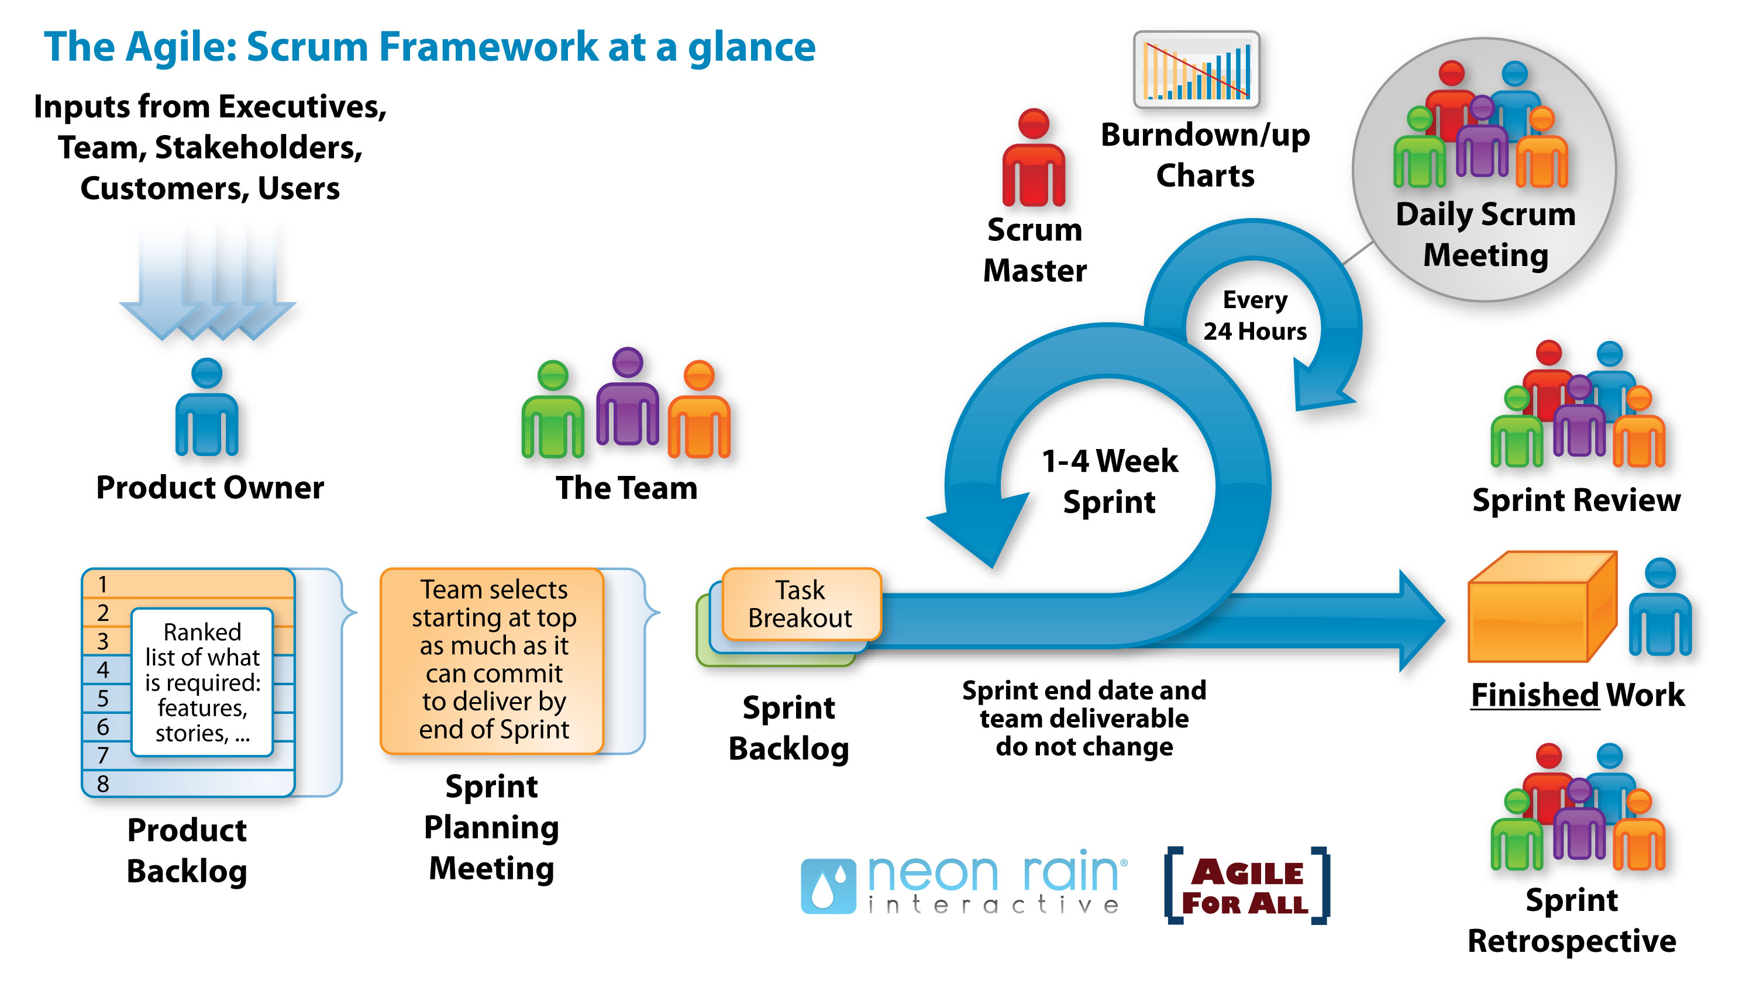

#### Extreme Programming:

Another Agile framework, Extreme Programming (or XP) focuses on producing higher quality software using the best practices in software development. As with most Agile approaches, XP allows for frequent releases in short development sprints that encourage change when needed.

In general, XP follows a set of values, rather than steps, including simplicity (develop what is required, nothing more); communication (teams must collaborate and work together on every piece of the software); consistent feedback; and respect.

Extreme Programming requires developers to first plan and understand the customer’s user stories—their informal descriptions of certain features. Other practices include: scheduling and dividing work into iterations. Design with simplicity in mind, code and test often, which helps to create fault-free software. Listen to feedback to best understand the functionality, and then test more. (Majewski, 2019)

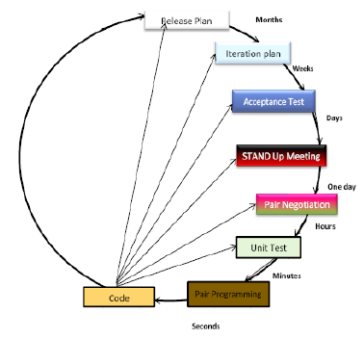

#### Lean:

Lean is at once a workflow methodology and a mindset, incorporating principles and practices from the manufacturing space and applying them broadly to a variety of industries, including software development. While Agile is an excellent methodology for the practical application of development best practices, it does not include instructions for scaling these practices across the organization or applying them outside of development-type work.

Lean’s basic principles—optimize the whole, eliminate waste, build quality in, create knowledge, defer commitment, deliver fast, and respect people—can help to guide decision-making across the organization in a way that can help to unearth potential issues and maintain a healthy organizational culture.

Combining the best of Lean thinking and Agile software development practices can create a healthy, sustainable culture of innovation that benefits not only the development organization, but the system as a whole. (Majewski, 2019)

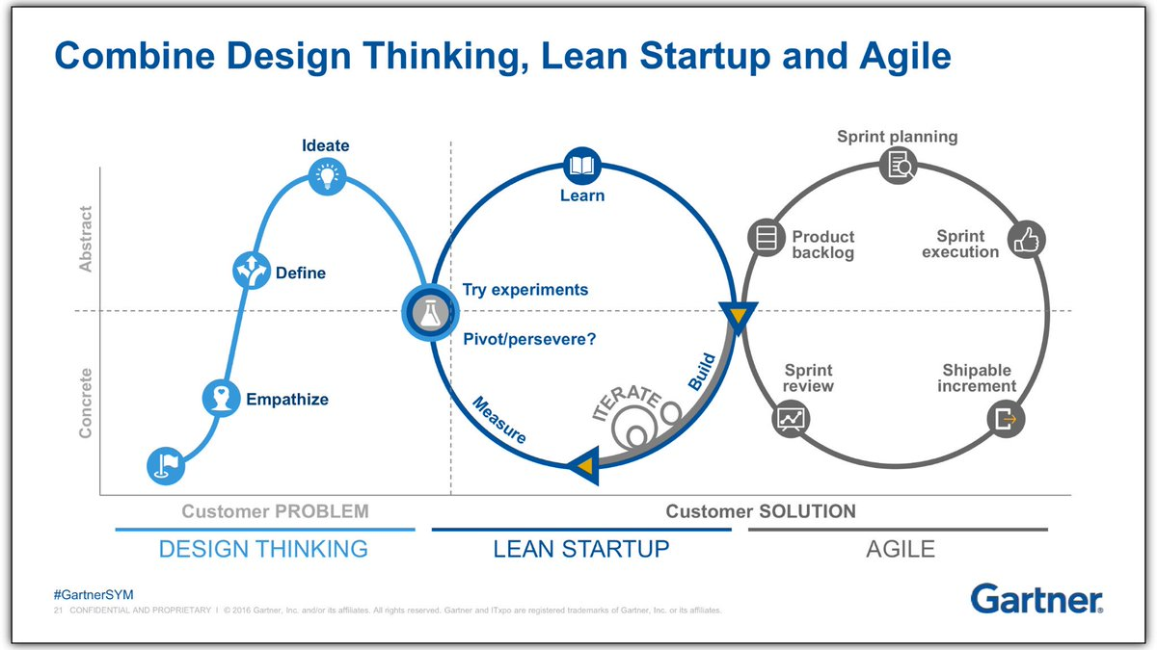

### Q11.

**Provide a definition of software development and configuration management processes.**

In software engineering, a software development process is the process of dividing software development work into distinct phases to improve design, product management, and project management. It is also known as a software development life cycle (SDLC). The methodology may include the pre-definition of specific deliverables and artefacts that are created and completed by a project team to develop or maintain an application.

Configuration management is a systems engineering process for establishing and maintaining consistency of a product's performance, functional, and physical attributes with its requirements, design, and operational information throughout its life.

# Rapid App Development

### Q12.

**Provide a description of quality assurance practices and standards as they relate to Rapid Application Development that could be used by CITE Managed Services.**

Software quality assurance is a process to ensure that any software development processes, activities, methods or work practices are checked to verify that they are complying with any defined standards that may affect the software development process. Business will choose to implement these standards in an effort to show commitment to its customers that it delivering quality products or services.

CITE Managed Services would do well to implement standard ISO 9001, as it covers:

* Requirements for a QMS, including documented information, planning and determining process interactions
* Responsibilities of management
* Management of resources, including human resources and an organization’s work environment
* Product realisation, including the steps from design to delivery
* Measurement, analysis, and improvement of the QMS through activities like internal audits and corrective and preventive action

### Q13.

**Provide a description of Rapid Application Development and outline the role of the client, and their involvement in each phase of RAD.**

Rapid Application Development refers to both a specific SDLC method, as well as a general term used to refer to an adaptive software approach. In general, RAD approaches to software development put less emphasis on planning and more emphasis on an adaptive process. Prototypes are often used in addition to or sometimes even in place of design specifications. RAD came about from the unique nature of software development, in that changes can be made almost immediately and even very late in the development process.

A client role in RAD development is very involved. Clients will be included throughout the life cycle of the development in each cycle, to provide requirements, constant feedback on ongoing progress, signing off that developed code functions as intended. This ensures that the client gets what they want, and due to the client’s constant involvement in the development, if a feature of code misses the mark, it can be quickly rectified.

### Q14.

**Describe the client business domain and then outline the impact it will have on RAD; in particular the effect on the overall cost and quality of the final application.**

A Client business domain is a term used to define a business’s core model, its staff or department structure or its workplace culture and values. It is important to understand any client business’s domain as much as possible, in order to provide better software for that company, and to help avoid specifying every single minute detail in a specification report. With larger organisations it can be assumed that an application will have larger scope than that of a similar application for a small company, this is due to an increased number of users, or range of users that will be using the application.

If the software developing team has little to no understanding of the client business domain, than more than likely the SDLC will take longer than expected, be under or overestimated, and in the worst case be ill fit for purpose and ultimately rejected by the client.

### Q15.

**Create a comparison table of contemporary RAD tools, add table headings like: targeted platform, RAD Type, cost, rating and major benefits. Your table should have more than 5 RAD tools.**

|  |  |  |  |  |  |
| --- | --- | --- | --- | --- | --- |
| Bitbucket | Salesforce Lightning | Angular | Google App Maker | GitHub | Microsoft Power Apps |
| https://financesonline.com/uploads/2016/03/bucketl.png | https://financesonline.com/uploads/2019/08/Salesforce-Lightning-logo2.png | https://financesonline.com/uploads/2020/06/angular-logo2.png | https://financesonline.com/uploads/2019/08/Google-App-Maker-logo2.png | https://financesonline.com/uploads/2016/03/ghl-1.png | https://financesonline.com/uploads/2018/02/Microsoft-PowerApps-logo-2.png |
| Pricing Model | | | | | |
| Free/ Monthly Payment | Quote Based | Quote Based | Monthly Payment | Monthly Payment | Monthly Payment/ Quote Based |
| Pricing | | | | | |
| $2 | By Quote | By Quote | $10 | $7 | $7 |
| Devices Supported | | | | | |
| Windows | | | | | |
|  |  | X |  |  |  |
| Android | | | | | |
| X | X | X | X | X |  |
| IPhone/IPad | | | | | |
| X | X | X | X |  |  |
| Mac | | | | | |
|  |  | X |  |  |  |
| Web-Based | | | | | |
|  |  |  |  |  |  |
| Customer Types | | | | | |
| Small Business | | | | | |
|  |  |  |  |  |  |
| Large Enterprises | | | | | |
|  |  |  |  |  |  |
| Medium Business | | | | | |
|  |  |  | X |  |  |
| Freelancers | | | | | |
|  | X | X | X |  | X |
| Deployment | | | | | |
| Cloud Hosted | | | | | |
|  |  | X |  |  |  |
| On Premise | | | | | |
|  | X |  | X | X |  |
| Open API | | | | | |
| X | X |  | X | X | X |

# References

Altvater, A. (2017, September 16th). *What Are Software Metrics and How Can You Track Them?* Retrieved October 29th, 2020, from Stackify: https://stackify.com/track-software-metrics/#:~:text=Metrics%20are%20an%20important%20component,to%20foster%20better%20team%20productivity.

Bhatia, S. (2020, August 24th). *Procedural Programming [Definition]*. Retrieved October 29th, 2020, from Hackr.io: https://hackr.io/blog/procedural-programming

Christensson, P. (2012, April 19th). *Java Definition*. Retrieved Obtober 29th, 2020, from TechTerms: https://techterms.com/definition/java#:~:text=Java%20is%20a%20high%2Dlevel,an%20object%2Doriented%20programming%20language.

Christensson, P. (2015, July 30th). *WIndows 10 Definition*. Retrieved October 29th, 2020, from TechTerms: https://techterms.com/definition/windows_10

Majewski, M. (2019, March 12th). *Top 6 Software Development Methodologies*. Retrieved October 29th, 2020, from Planview Blog: https://blog.planview.com/top-6-software-development-methodologies/

Microsoft Docs. (2018, October 17th). *Windows Kernel-Mode I/O Manager*. Retrieved October 29th, 2020, from Microsoft Docs: https://docs.microsoft.com/en-us/windows-hardware/drivers/kernel/windows-kernel-mode-i-o-manager#:~:text=A%20computer%20consists%20of%20various,devices%20and%20the%20operating%20system.

Pratt, M. (2013, July 24th). *5 Essential Hardware Products for Starting Your Business*. Retrieved October 29th, 2020, from business.org: https://www.business.org/it/hardware/essential-hardware-products-for-starting-your-business/

Roman, P. (2018, December 11th). *Top 5 features of Windows Server 2019*. Retrieved October 29th, 2020, from Microsoft Tech Community: https://techcommunity.microsoft.com/t5/itops-talk-blog/my-top-5-features-in-windows-server-2019/ba-p/299378

Techlabs, M. (2018, June 18th). *11 Best Prototyping Tools For UI/UX Designers — How To Choose The Right One?* Retrieved October 29th, 2020, from The UX Blog: https://medium.theuxblog.com/11-best-prototyping-tools-for-ui-ux-designers-how-to-choose-the-right-one-c5dc69720c47

Technopedia. (2018, May 21st). *C Programming Language (C)*. Retrieved October 29th, 2020, from Technopedia: https://www.techopedia.com/definition/24068/c-programming-language-c#:~:text=C%20is%20a%20high%2Dlevel,System%20in%20the%20early%201970s.